**Environmental Geophysics**

October 15, 2020

Due: October 22, 2020 at 11:59 pm.

Dr. Dan McGrath

Activity 4 – Slope Degradation

Your name:_______________________________

**Learning Objectives:**

* Learn about a specific application of high-resolution surface topography derived from lidar and/or SfM surveys
* Learn how fault scarps degrade through time via geomorphic processes
* Model scarp degradation via diffusion modeling

This assignment is based on: <https://serc.carleton.edu/getsi/teaching_materials/high-rez-topo/unit3.html>, with special thanks to Nicholas Pinter, Ramon Arrowsmith, and Sean Gallen.

Please answer in complete sentences and include units, where appropriate.

_____________________________________________________________________________

# Introduction

*Fault scarps form when a fault ruptures the earth surface in a seismic event and are topographic evidence of past earthquakes. The study of fault scarps leads to important insight into the history of faulting during the Quaternary, and provides a way to constrain magnitude and frequency of paleoseismic events. The magnitude of a slip event can be estimated using maximum fault displacement to magnitude relationships. Frequency may be derived from scarp morphology. In the case of normal faults, scarps are observed to initially form as a step-shaped landform. Over time, fault scarps deteriorate due to erosional processes. Their peak slopes decrease, and the overall shape of the step degrades. The form of the scarp may also indicate it was formed by multiple slip events, and the offset of each of these events with the relative ages estimated from the morphology of the surface can be used to calculate the frequency of events.*

*Scarps fall into two categories: weathering-limited and transport-limited. Weathering-limited scarps do not weather as quickly as material is transported away; these scarps are generally composed of bedrock. The eroded material sometimes present at the base of a bedrock scarp can be used for erosion models to predict recurrence intervals. It is generally assumed that scarps develop in unconsolidated material initially reflect the propagation of the fault plane to the surface. Transport-limited scarps weather more quickly than material is transported away, so over time these scarps tend toward the angle of repose of the material composing the scarp. This can be modeled as a diffusion process.*

**Diffusion Modeling**

The evolution of a transport-limited slope through time can be evaluated quantitatively by assuming that sediment transport is a diffusion process. Diffusion also describes how chemicals in solution move from areas of high concentration to areas of low concentration, and how heat moves from areas of high temperature to areas of low temperature. In sediment diffusion, gravity carries sediment from an area of high elevation (the top of the slope) towards an area of low elevation (the base of the slope). Without fresh uplift or downcutting, diffusion tends to make slopes smoother and less steep over time.

1

2 3

4

5

6 7

8

Figure 1. An elevation profile across a slope is measured at several points.

In the field, a geologist typically measures the elevations of a series of points in a line perpendicular to the scarp using surveying equipment. The heights of those points and the distances between them are used to construct a cross section.

In order to calculate rates of sediment diffusion, it is necessary to subdivide a slope into a series of short segments. Calculations are easiest if all segments have the same width. If a slope has been profiled in the field, then slope segments can be the intervals between measured points. Diffusion models look at each of these segments as a tall column of sediment (Figure 8.2). Like a series of small basins over which a waterfall flows, each segment receives input (water on the waterfall; sediment on the slope) from the segment above it and sends discharge into the segment below.



1

2

3

4

5

6

7

8

Figure 2. In order to model a slope, it is convenient to imagine the slope as several discrete segments with sediment moving from the highest segment into successively lower segments.

Sediment diffusion can be evaluated quantitatively by using the **Continuity Equation**:

z = R (1)

t x

where **z** is the height (elevation) at any given point an a slope, **R** is the rate of sediment movement, **x** is horizontal distance, and **t** is time (Table 1 below summarizes all the parameters used in this chapter). The Continuity Equation is one of the simplest equations in science – translated into English, it simply states that the change in elevation through time at a point equals the difference between the amount of sediment *arriving at* that point and the amount of sediment *leaving.* For example, a 10 m wide slope segment that receives 20

m2 of sediment from upslope (on a two-dimensional cross section, volume is measured in m2) and sends 30 m2 downslope thereby loses 10 m2, and an average of 1 m of material erodes from that 10 m length of the slope.

Table 1. Parameters used in calculating slope diffusion.

|  |  |  |
| --- | --- | --- |
| **Parameter** | **Explanation** | **Units** |
| z | elevation | meters |
| t | time | years |
| R | sediment flux rate | m2 / yr |
| x | horizontal position | meters |
| z/t | elevation change over time | m / yr |
| R/x | change in transport rate | m2 / yr 2 |
| $$Κ$$ | diffusivity | m2 / yr |
| z/x | slope gradient | none |

There is a second equation on which diffusion modeling is based. This equation relates the rate of sediment transport (R), a constant ($Κ$, called *diffusivity)*, and the slope gradient (z/x):

Eq. 2

Other, more complicated versions of this equation exist, but this simpler version can be used where sediment transport is caused mainly by creep. The diffusivity constant ($Κ$) is very important here. Diffusivity characterizes how easily the sediment can be moved and how much the local climate can move it. Diffusivity varies substantially from one area to another. In order to estimate the sediment-transport rate (R), it is necessary to measure diffusivity in the field or infer it indirectly.

## Part 1. FAULT-SCARP DEGRADATION

A *scarp* is defined as a steep slope or a steep portion of a larger, less steep slope. Scarps can form as a result of many different geomorphic processes. *Fault scarps* form when a fault ruptures the surface during an earthquake. Quantitative modeling of sediment diffusion has proven extremely useful when it is applied to fault scarps. Specifically, when a geologist identifies a fault scarp in the field, he or she most commonly wants to find out *when* the earthquake that caused that fault scarp occurred. Given the shape of the fault- scarp profile, given assumptions about how the scarp looked when it first formed, and given the value of the diffusivity constant, the geologist can estimate when the scarp formed.

Fault scarps that cut unconsolidated sediment or soil are very promising for diffusion modeling because they form instantaneously and then systematically degrade afterwards. Older fault scarps are smoother and less steep than recent fault scarps. In principle, a geologist could measure a profile across any fault scarp and then calculate exactly how much time is represented by the degradation of the profile. In practice, several criteria must be met for a solution to be possible:

1. The scarp must be transport-limited. Fault scarps on bedrock cannot be modeled using diffusion.
2. After the earthquake occurred, the scarp must have quickly collapsed to the angle of repose (25-30° in sand).
3. It must be possible to measure, infer, or assume a value for diffusivity ().
4. The scarp must have formed in a single rupture event.

Of these criteria, the third assumption is often the most difficult to meet. It’s never possible to determine the age of a fault scarp without knowing the value of diffusivity. One method for inferring diffusivity is outlined in the exercise that follows.

Given the four criteria above, several solutions give the time (t) since a fault scarp formed. The following is the solution given by Colman and Watson (1983):

(3)

$$Κt=\frac{d^{2}}{4π} \frac{1}{{(\tan{θ}-\tan{α})}^{2}}$$

where d is the vertical separation between the upper slope and the lower slope,  is maximum scarp angle, and  is far-field slope angle (see Table 2). These parameters can be measured easily on a cross section across a fault scarp, as illustrated in Figure 3.

Table 2. Additional parameters for calculating fault-scarp degradation (also see Table 1 and Figure 3).

|  |  |  |
| --- | --- | --- |
| **Parameter** | **Explanation** | **Units** |
| d | vertical displacement on a scarp | meters |
| ❐ | pi = 3.14159 | none |
| ❑ | maximum scarp slope angle | degrees |
|  | average far-field slope angle | Degrees |

1

1

d

❑

2

|  |  |
| --- | --- |
| ❑ | maximum slope of modern scarp |
|  | average far-field slope (= ( 1+ 2)/2) |
| d | surface offset |

2

Figure 3. Measurements that need to be made on a fault scarp in order to solve Equation 3.

Q1) Using the elevation and distance measurements for the ten points in profile A-A’, plot a cross section of the fault scarp (10).

12.0

V.E.= 5

10.0

|  |  |  |
| --- | --- | --- |
| Point # | Dist. (m) | Height (m) |
| 1 | 0 | 0.00 |
| 2 | 10 | 0.30 |
| 3 | 20 | 0.90 |
| 4 | 30 | 2.00 |
| 5 | 40 | 4.20 |
| 6 | 50 | 7.50 |
| 7 | 60 | 8.70 |
| 8 | 70 | 9.80 |
| 9 | 80 | 10.40 |
| 10 | 90 | 10.60 |

8.0

Height (m)

6.0

4.0

2.0

0.0

0 20 40 60 80

Distance (m)

Q2) Calculate the gradient angle between points #1 and #2 and the gradient angle between Points #9 and #10 (remember that a gradient angle equals arctan[rise ÷run]). You should see that these two angles are 1 and 2. Calculate  for this scarp. (5)

Q3) Find the steepest interval between adjacent points on this profile. Calculate the gradient angle of that interval. This angle is . (5)

Q4) Using the graph on the above, calculate d for this scarp. (5)

Q5) Assume that this fault formed 120 years ago (t=120 yrs). Use Equation 3 to calculate the value of diffusivity on this scarp. (10)

## Part 2. The Two-Scarp Problem

A geologist has identified two fault scarps along an active fault zone. Historical records show that one of the scarps (Scarp A) formed during a damaging earthquake 200 years ago. The other scarp (Scarp B) formed during some unknown earthquake during prehistoric time.

# Fault scarp A

ruptured 200 years ago (t = 200 yrs)

❑ = 9.2°

 = 1.2°

8

6

meters

4

2

0

# Fault scarp B

same climate and material as A age unknown

❑ = 3.5°

 = 1.4°

8

6

meters

4

2

0

Q6) Using Scarp A, calculate the value of diffusivity (). (10)

Q7) Assuming that the two scarps are cut in the same material, estimate the age of the earthquake that formed Scarp B. (10)

Q8) Given only the information in this two-scarp problem, estimate the average recurrence interval of large earthquakes on this fault zone. (5)

**Part 3. Finite Difference solutions to profiles**

This portion of the activity will use an explicit finite difference solution implemented in Matlab (by our very own tectonic geomorphologist, Dr. Sean Gallen!) to solve the diffusivity equation to calculate surface topography evolution through time. To start this part of the activity, download the script (diffusion_script.m), the function (simple_diffusion_model.m) and the two profiles (Profile.xlsx and Profile2.xslx) from Canvas and place them into your working directory in Matlab.

You should just be able to open the diffusion_script.m script and press Run to produce the figure below. This is based on specifying the initial and final elevation profiles, a K value, and a model run time (age of the earthquake that produced the scarp). For the first part, we’ll assume we know the age of the scarp as 10,000 years and your task is to calculate the K value that results in the lowest RSS.

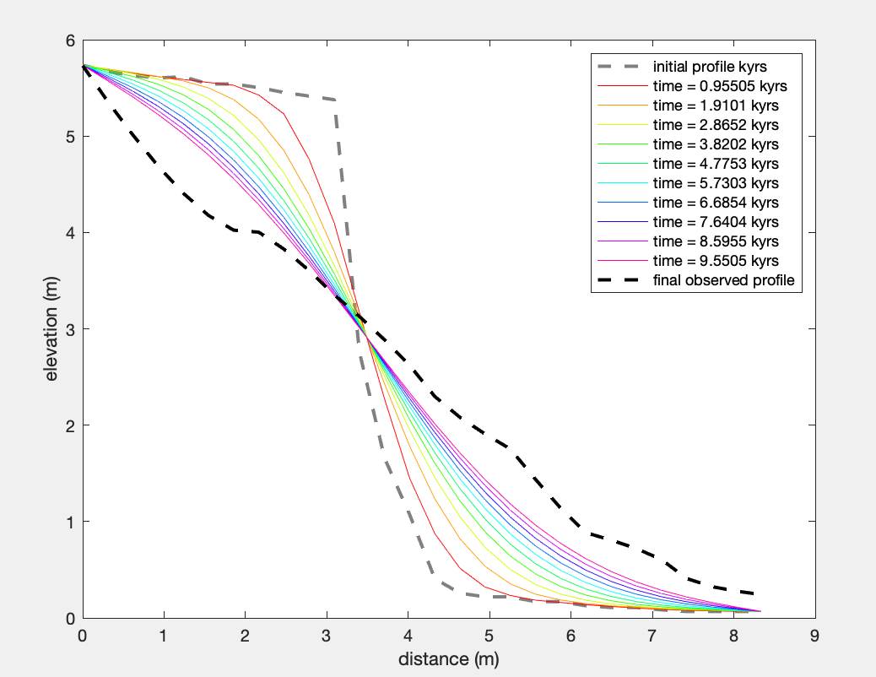

Rather than manually changing the K value repeatedly, the optimal (and recommended) way to accomplish this is to wrap this script in a “for loop” such that it will run through a set of K values and record the RSS for each iteration.

Below is an initial template to get you started. You’ll need to create an array to record the rss during each iteration and if you want, additional code to produce the figure shown below.

% load the excel file

data = readtable('profile_data.xlsx'); %be sure this is profile_data for this part

% unpack the data

x = data.distance_m_; % distance along the profile

zi = data.initialElevation_m_; % initial elevation of the observed profile

zf = data.finalElevation_m_; % final elevation of the observed profile

kk=xx:xx:xx; % define start:increment:end values for K

for i=1:length(kk)

% define parameters

%k = 0.1; % diffusion parameter m^2/kyr

k=kk(1,i); %this grabs the next diffusion parameter

run_time = 10; % model run time in kyr

% run the model

[z_mod,rss] = simple_diffusion_model(x,zi,zf,k,run_time,'plot_opt',0);

end

Following this, you can use the function below to find the index (I) for the minimum RSS value. With the index, you can calculate the corresponding K value.

[M,I] = min(RSS);

min_K=kk(1,I);

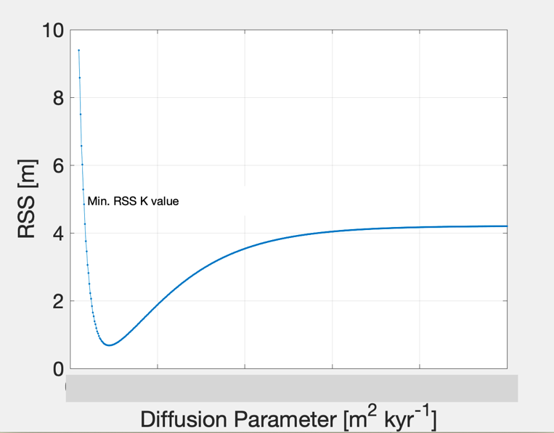

9) What K value results in the minimum rss for the specified age of 10,000 years (10kyr)? (20)

For the next part, we’re going to rearrange the equation and use the K value you calculated previously to calculate the age of a different scarp (in the same region and therefore K should be valid) that has a different elevation profile (this profile can be found in profile_data2.xslx).I recommend saving your script with a different name (such as diffusion_script_time.m) before you starting making modifications.

Now, rather than your “for loop” consisting of a vector of K values, you will specify the K value you found previously and then subsequently run through a series of different run_times (this is the age of the earthquake). I’d recommend doing something similar where you plot the RSS as function of model run_time and then use the min function to determine the model_run time resulting in the lowest RSS.

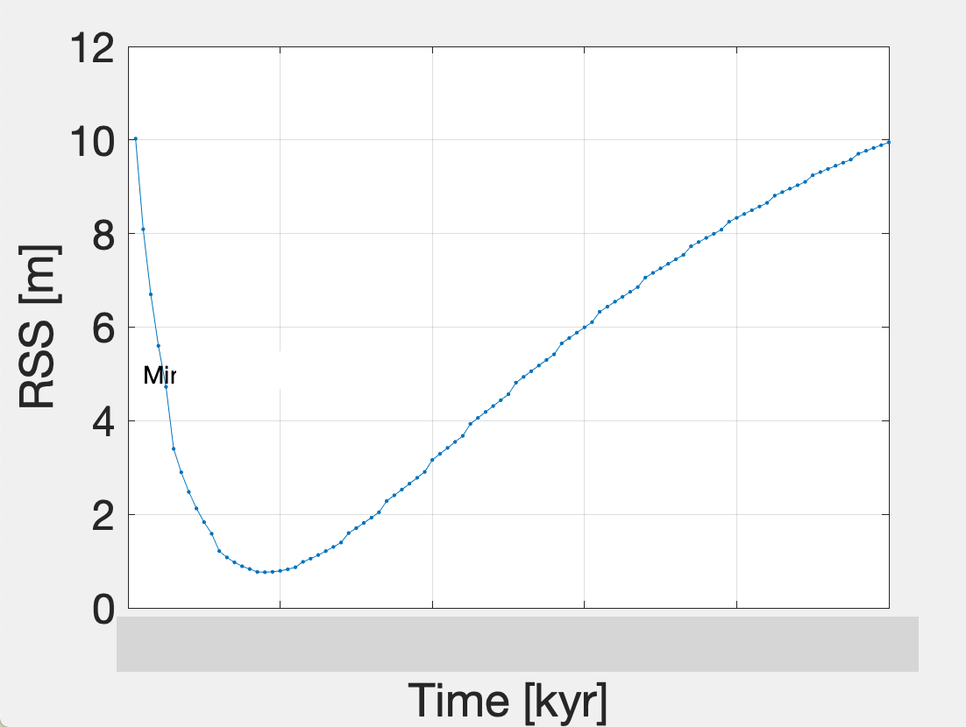

10) What run_time results in the lowest RSS? (20). This is the estimated age for this earthquake scarp. Hint: it should be less than 10,000 years, as the profile is less well developed than the first profile we looked at.